Data are the record of communications and activities, much of it used to record human communications and activities. Data consists of the numbers used to count, measure and identify people, places, things and activities. Data also consists of words and pictures used to describe people, places, things and activities

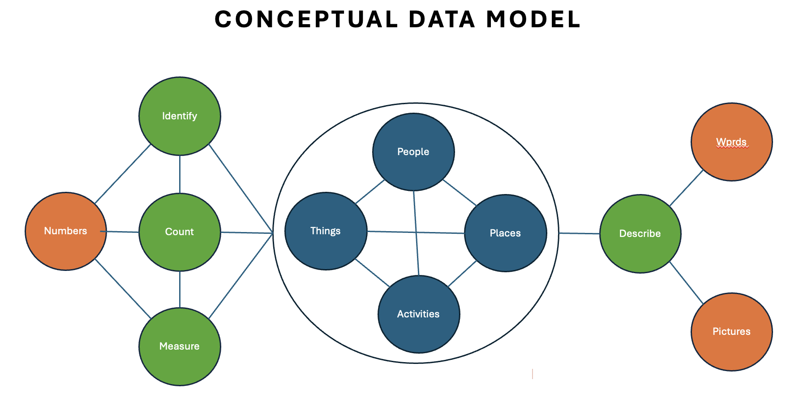

This Diagram beginns to illustrate the many relationships that provide data structure; a hyper-relational structure.
The diagram does not incorporate the two important dimensions: time and context. Numbers (counts and measurements) are ‘facts; that are accurate at the moment-of-record, necessitating the repetitive recording of ‘values’. This is commonly referred to as time-series data. Words and pictures are slightly less time sensitive. We manage numbers in databases, words and pictures are filed.
The contextual dimension is ‘Metadata’: data about data. Metadata describes relationships.
Analysis is the process of identifying relationships. Analysis is fundamental to learning. When learning is committed to memory it’s knowledge. When knowledge is associated with consequences, it’s Intelligence. Intelligence must be infused with knowledge.
Mathematical analysis of numbers produces data to support quantitative analysis. Relationships are incorporated into mathematical models. To support quantitative analysis, we create databases. The most popular tool used for quantitative analysis is the two-dimensional spreadsheet. Development of three-dimensional data cubes advanced to multi-dimensional databases. Our ability to accomplish advanced mathematical analysis increased with advances in numeric data management.
AI technologies are a breakthrough in qualitative data modeling. Once again, we are modeling data – Textual and pictorial – relationships associated with People, Places, things and actives.

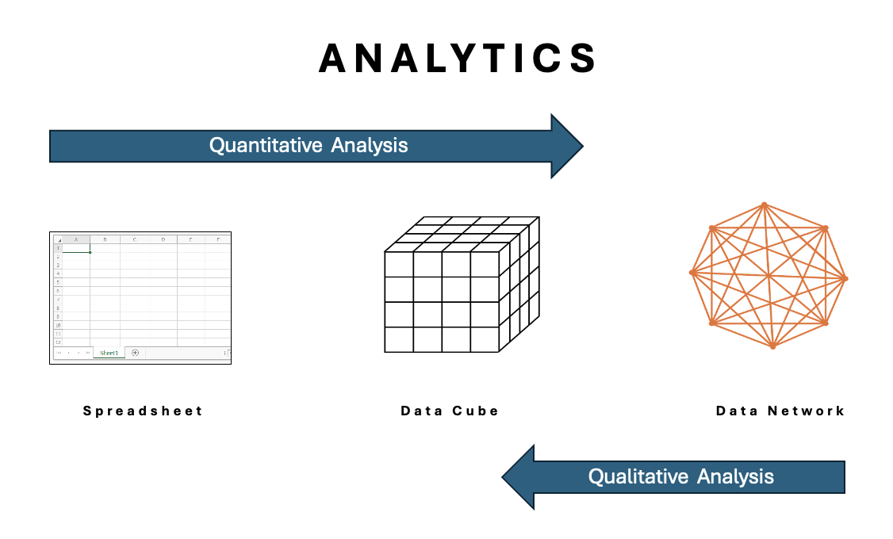

The future of analytics is the combination of quantitative and qualitative analysis. this can only be accomplished by developing a multidirectional, unconstrained, Hyper-Relational Data Network.
The Star Schema popularized a data model that surround facts and values with dimensions: Time, people, places and things. This supported an outside-in approach to formulating database queries. A Data Network supports a start-anywhere, bidirectional approach to querying a database, infused with knowledge. It represents an approach to learning that reflects how people learn.
I believe:
Generating an answer creates more questions . . . answers redirect questioning . . . this is the non-stop questioning sequence known as ‘Critical Thinking’. I want to shift the conversation from Machine learning to human critical thinking.
Reporting facts without descriptions is meaningless. Answers without the facts are opinions.
Quantitative Analysis requires the infusion of knowledge!
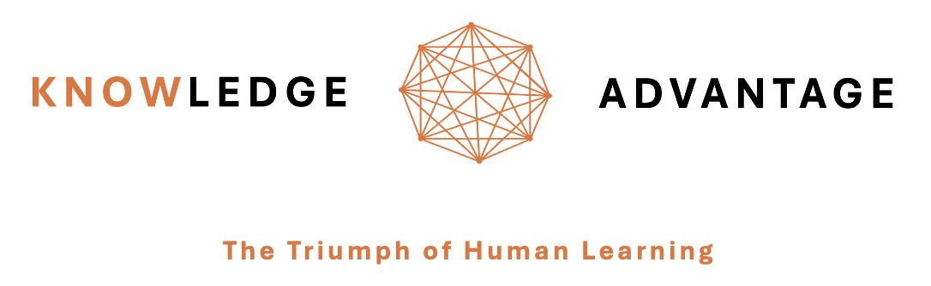

I formed Knowledge Advantage, LLC in January of this year. My vision was to employ AI to develop a database for advancing human learning. Prior to founding Knowledge Advantage, I worked with a developer (Tomaz Bratanic, now employed by Neo4J) to confirm feasibility of using GPT4 to produce a knowledge graph from published biomedical literature. We stated with literature sourced from PubMed related to the prevention of dementia. Tomaz developed a graph database loading algorithm within a few days. So, I began thinking about how this graph database could be turned into a transformative personalized learning experience. I focused on developing requirements for a chronic disease personalized learning experience that would be vastly superior to text-based patient education.
I became convinced that AI + Graph technologies are the future of all manner of human learning. LLM’s need to be context specific and as accessible as a Datawarehouse. AI alone is just spitting out answers.
I was making progress but had an accident in January that sidelined me with broken ribs. Then my wife had a more serious accident in March. She did not recover.
I read what you write and feel we are on the same path. We both see the opportunities at the confluence of Big Knowledge, AI and Graph Database development. 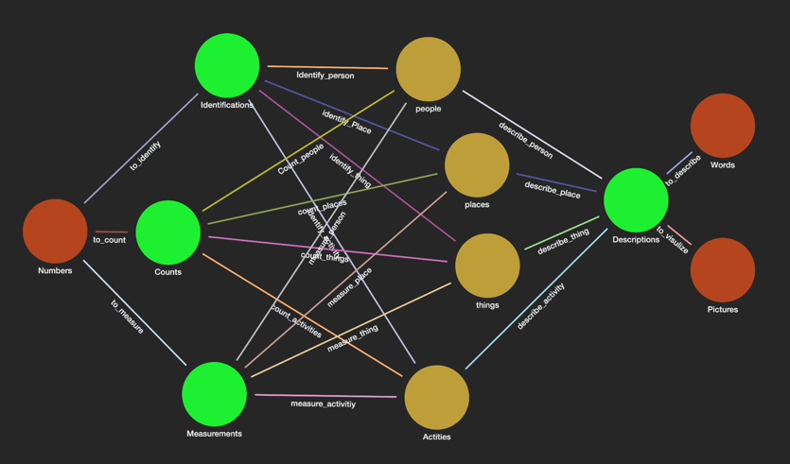
I think AI has reached the peak of its hype cycle. What’s next? I think it is the repositioning of AI to be a database development tool, creating a database for ad-hoc human leaning.
Rick

